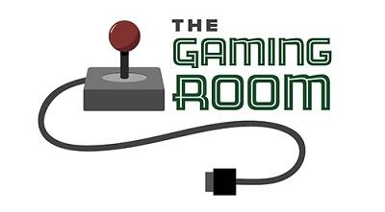

The Gaming Room

CS 230 Project Software Design Template
Version 1.2

Table of Contents

1.CS 230 Project Software Design Template 1
Table of Contents 2
Document Revision History 2
Executive Summary 3
Requirements 3
Design Constraints 3
System Architecture View 3
Domain Model 3
Evaluation 4
Recommendations 5
2.Operating Platform: <Recommend an appropriate operating platform that will allow The Gaming Room to expand Draw It or Lose It to other computing environments.> 5
3.Operating Systems Architectures: <Describe the details of the chosen operating platform architectures.> 5
4.Storage Management: <Identify an appropriate storage management system to be used with the recommended operating platform.> 5
5.Memory Management: <Explain how the recommended operating platform uses memory management techniques for the Draw It or Lose It software.> 5
6.Distributed Systems and Networks: <Knowing that the client would like Draw It or Lose It to communicate between various platforms, explain how this may be accomplished with distributed software and the network that connects the devices. Consider the dependencies between the components within the distributed systems and networks (connectivity, outages, and so on).> 5
7.Security: <Security is a must-have for the client. Explain how to protect user information on and between various platforms. Consider the user protection and security capabilities of the recommended operating platform.> 5

Document Revision History

Version | Date | Author | Comments
1.0 | 11/15/25 | Amanda Celi | Document completed
1.1 | 11/28/25 | Amanda Celi | Reviewed Evaluation Table section for Project Two submission
1.2 | 12/04/25 | Amanda Celi | Reviewed Recommendations section for Project Three submission

Executive Summary

The Gaming Room is seeking to expand its current Android-only game, Draw It or Lose It, into a web-based, multi-platform application capable of supporting multiple teams and players simultaneously. The client requires a solution that ensures the uniqueness of games, teams, and players, while also maintaining efficient performance in a distributed environment. To address these needs, this design proposes an object-oriented architecture supported by robust software design patterns, including the Singleton pattern for centralized game management and the Iterator pattern for validating unique identifiers across collections.
This design solution leverages a layered and modular structure to promote scalability, maintainability, and platform flexibility. By implementing a shared base Entity class and extending it for Game, Team, and Player, the structure enforces consistency and reduces code redundancy. Implementing the GameService as a Singleton ensures that only one instance of the service manages all game activity, supporting memory integrity and preventing concurrency issues. The resulting architecture enables The Gaming Room to deliver a reliable, efficient, and scalable web-based application capable of serving diverse devices and operating systems while upholding the integrity and user experience of the original game.

Requirements

The Gaming Room requires a web-based implementation of Draw It or Lose It that supports the following business and technical needs:
- Multi-platform compatibility (Windows, macOS, Linux, mobile browsers).
- Support for one or more teams per game and multiple players per team.
- Unique names for all games, teams, and players.
- Only one instance of any game may exist in memory at a time.
- System must efficiently create and manage unique identifiers for all entities.
- Application behavior must remain consistent across distributed devices and networks.
- Code must be maintainable, scalable, and follow object-oriented best practices.

Design Constraints

Developing a web-based distributed version of Draw It or Lose It introduces several design constraints that directly influence the architectural decisions:

1. Distributed Environment Constraints
The application must operate seamlessly across networks with varying bandwidth, latency, and reliability. This limits the use of heavy local processing and requires the server to efficiently coordinate game state across all connected clients. Additionally, distributed systems introduce concurrency challenges that require careful state management.

2. Platform Diversity
Because users will access the game from multiple operating systems and devices, the design must avoid platform-specific dependencies. Web technologies such as HTML5, and JavaScript allow the system to remain the same despite the device and ensure broad compatibility.

3. Uniqueness and State Integrity
Each game, team, and player must maintain a unique name. This constraint requires implementing search and comparison logic using iteration patterns before creating new entities. Additionally, only one instance of a game may exist in memory at any time, requiring centralized, controlled object creation.

4. Memory and Resource Management
To prevent memory leaks or redundant objects in a distributed environment, the GameService class must follow the Singleton pattern. This ensures a single authoritative instance manages all active game data, reducing unnecessary resource usage.

5. Security Constraints
Because users interact with the system across the internet, secure communication is essential. Input validation, name uniqueness enforcement, and protection of user data must be considered within the distributed system. A consistent security approach across all clients ensures reliability.
These constraints collectively guide the architecture toward a structured, object-oriented system that uses established patterns to maintain integrity, security, and performance within a distributed environment.

System Architecture View

Please note: There is nothing required here for these projects, but this section serves as a reminder that describing the system and subsystem architecture present in the application, including physical components or tiers, may be required for other projects. A logical topology of the communication and storage aspects is also necessary to understand the overall architecture and should be provided.

Domain Model

The UML class diagram provided outlines the structure of the game application and demonstrates several key object-oriented design principles. At the center of the model is the Entity class, which serves as an abstract representation of objects that share common attributes, specifically an id and name. This class enforces consistency and promotes reusability across the system. The Game, Team, and Player classes inherit from Entity, demonstrating the principle of inheritance by extending common attributes and behaviors while adding their own functional components.
The system models real-world relationships using hierarchical associations. A Game contains one or more Team objects, and each Team contains one or more Player objects. This reflects a one-to-many aggregation relationship between the classes. GameService acts as the central controller responsible for creating and managing all Game instances. Its Singleton implementation demonstrates encapsulation and controlled access, ensuring the integrity of game data by restricting the creation of multiple service objects. The use of the Iterator pattern within methods such as addGame(), addTeam(), and addPlayer() demonstrates how the system enforces name uniqueness and searches through collections efficiently.
Overall, the UML illustrates key OOP principles including inheritance, abstraction, encapsulation, and the Single Responsibility Principle, as each class has a well-defined purpose. Together, these patterns support the client’s requirements and ensure the application’s scalability and maintainability in a web-based distributed environment.

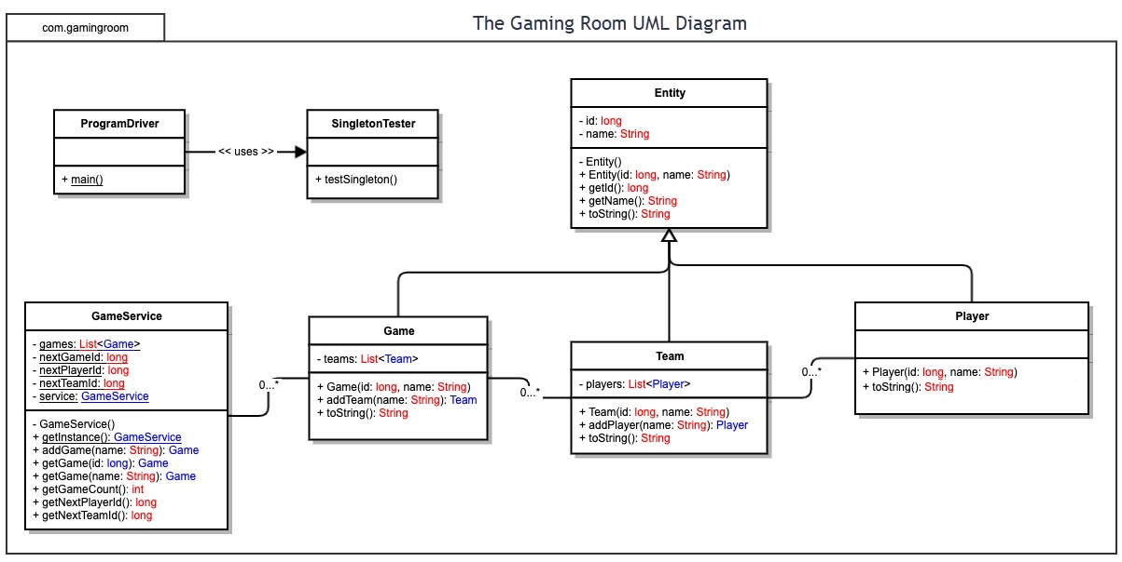

Evaluation

Using your experience to evaluate the characteristics, advantages, and weaknesses of each operating platform (Linux, Mac, and Windows) as well as mobile devices, consider the requirements outlined below and articulate your findings for each. As you complete the table, keep in mind your client’s requirements and look at the situation holistically, as it all has to work together.

In each cell, remove the bracketed prompt and write your own paragraph response covering the indicated information.

Development Requirements | Mac | Linux | Windows | Mobile Devices
Server Side | Stable UNIX-based environment  Good security and performance  High hardware cost  Not common for enterprise servers  Limited server-side support compared to Linux | Industry standard for servers  High stability, speed, and scalability  Free and open-source  Excellent performance for distributed systems  Requires command-line expertise | User-friendly administrative tools  Strong enterprise software integration  High licensing cost  Requires more system resources  Occasional reboots after updates | Not suitable for hosting  Limited processing power  No persistent server processes  Designed strictly for client-side use
Client Side | Excellent browser support (Safari, Chrome)  Strong performance and UI quality  Some web APIs behave differently in Safari  Higher device cost for end users | Flexible and customizable  Works well with Firefox and Chromium  Browser experience varies by distribution  May require additional compatibility testing | Most common desktop OS  Broad browser support (Chrome, Edge, Firefox)  Predictable environment for web apps  Hardware variability requires broader testing | Essential for broad user access  Requires responsive design and optimized assets  Wide variety of screen sizes and browsers  Hardware limitations compared to desktops
Development Tools | Xcode, IntelliJ, Eclipse, VS Code  Terminal + Homebrew for packages  Strong support for Java and web development  Limited compatibility with some Windows-specific tools | Git, Java, Eclipse, IntelliJ, Docker  Native support for servers and open-source tools  Highly customizable environment  Steeper learning curve for new developers | Visual Studio, IntelliJ, Eclipse, VS Code  Easy setup and wide tool support  Works well for web and Java development  Some UNIX-based workflows require extra setup | Only light coding or testing tools available  Cloud-based IDEs only  Not suitable for full development workflows  Primarily for testing browser behavior

Recommendations

Analyze the characteristics of and techniques specific to various systems architectures and make a recommendation to The Gaming Room. Specifically, address the following:

- Operating Platform: The recommended operating platform for expanding Draw It or Lose It to other environments is Linux. Linux offers unmatched stability, scalability, and performance for hosting distributed web applications. It is also cost-effective due to its open-source nature and is widely supported by cloud hosting providers such as AWS, Azure, and Google Cloud. Linux’s lightweight architecture makes it ideal for handling multiple simultaneous game sessions while maintaining fast server response times.

- Operating Systems Architectures: A Linux-based architecture is the ideal choice, as it supports efficient multitasking, excellent memory management, and robust security features. Linux kernel architecture allows scalable handling of processes that are essential for managing real-time game sessions across distributed clients. Additionally, the modular structure of Linux enables administrators to optimize the environment by installing only the components required by the game server.

- Storage Management: A cloud-based storage system with redundancy, such as Google Cloud Storage, is recommended. These systems ensure high availability, automatic backups, and scalable storage capacity suitable for game assets, user data, and logs. Using distributed storage also isolates persistent data from server failures, ensuring continuous availability for users across multiple platforms.

- Memory Management: Linux provides superior memory management due to its efficient kernel scheduling, dynamic caching, and low overhead. These features reduce resource consumption and ensure that the game server can handle large numbers of concurrent users without performance degradation. Memory allocation in Linux is predictable and optimized for server environments, reducing the risk of bottlenecks or crashes while running a game application.

- Distributed Systems and Networks: To support communication across multiple devices and platforms, the application should use standardized web protocols such as HTTPS and WebSockets. A distributed architecture allows players to connect from any device and ensures their interactions are synchronized in real time. Redundancy, load balancing, and failover servers should be considered to maintain uptime even during outages or heavy traffic. Network dependencies must be continuously monitored to avoid communication delays or interruptions.

- Security: Security is essential for protecting user data and maintaining system integrity across distributed devices. HTTPS communication, strong authentication, sanitized input handling, and server-side validation should be implemented to prevent attacks such as injection, spoofing, and data interception. Linux’s robust permission model and built-in firewall tools enhance the overall security posture. Consistent monitoring, patching, and user-access control must be maintained to ensure all platforms remain protected.

